ICS-344 - Information Security
Section 02
Ali Kamal Aloryd 202322750
Redha Abdulaziz Alturaik 20232301
http://dvsa-website-test-546079881937-us-east-1.s3-website.us-east-1.amazonaws.com/
us-east-1 (N. Virginia)
Date: 19 April 2026
Sensitive Information Disclosure
Lesson - 3

Goal and Vulnerability Summary
This lesson demonstrates a Sensitive Information Disclosure vulnerability in DVSA where an authenticated user can access another user’s private order and receipt information by modifying only the order-id parameter in the API request. The main affected component is the backend Lambda function DVSA-ORDER-GET, which retrieves order details through API Gateway and DynamoDB.
The intended behavior is that users should only be able to access their own orders and receipts. However, the application validates authentication only and does not properly verify ownership of the requested order. As a result, a normal user can access another user’s sensitive data including address, phone number, payment details, and internal user identifiers. This creates a serious confidentiality and privacy risk. The project specifically emphasizes that vulnerabilities often appear due to missing authorization and validation inside the request lifecycle between API Gateway, Lambda, and backend storage.

Why This Works / Root Cause
The vulnerability exists because the backend trusts the provided order-id without verifying whether the authenticated user actually owns that order. The Lambda function checks whether the request contains a valid authentication token, but it does not enforce proper authorization before returning sensitive order details.
Additionally, a backend implementation bug existed in the isAdmin handling logic:
is_admin = json.loads(event.get("isAdmin", "false")).lower()
Since json.loads("false") returns a Boolean value (False) rather than a string, calling .lower() caused the function to crash with the error:
'bool' object has no attribute 'lower'
This bug initially blocked the exploit from completing cleanly, but after correcting this type-handling issue, the real authorization flaw became fully visible.

Environment and Setup
The DVSA environment was deployed in AWS us-east-1 (N. Virginia) using the AWS Serverless Application Repository. The public frontend was hosted on Amazon S3, while the backend used API Gateway, AWS Lambda, and DynamoDB.
The main Lambda function involved in this lesson was:
DVSA-ORDER-GET
The API endpoint used for testing was:
https://h3x14rchv6.execute-api.us-east-1.amazonaws.com/dvsa/order
Two normal users were created:
User B → attacker
User C → victim
Both users placed at least one order. Browser DevTools (Network tab), curl, jq, AWS Lambda Console, and CloudWatch were used during testing.
The victim’s order-id used for exploitation was:
2d3f476f-b936-4901-b1dd-18946ff8ba25

Reproduction Steps
Step 1 - Confirm Authentication Exists
An unauthenticated request was sent directly to the /order API endpoint without an authorization token:
curl -s "https://h3x14rchv6.execute-api.us-east-1.amazonaws.com/dvsa/order" \
-H "content-type: application/json" \
--data-raw '{"action":"get","order-id":"2d3f476f-b936-4901-b1dd-18946ff8ba25"}' | jq
The backend returned:
{"error":"Invalid token format"}
This confirmed that authentication was required.
Step 2 - Attempt Cross-User Access
export TOKEN="<User B Token>"
BODY='{"action":"get","order-id":"2d3f476f-b936-4901-b1dd-18946ff8ba25"}'
curl -s "https://h3x14rchv6.execute-api.us-east-1.amazonaws.com/dvsa/order" \
-H "content-type: application/json" \
-H "authorization: $TOKEN" \
--data-raw "$BODY" | jq
Initially, the backend crashed with:
'bool' object has no attribute 'lower'
This showed that the request reached the backend but failed due to an internal type-handling bug.
Step 3 - Patch the Backend Bug
Inside Lambda function DVSA-ORDER-GET, the following vulnerable line was found:
is_admin = json.loads(event.get("isAdmin", "false")).lower()
It was changed to:
is_admin = str(event.get("isAdmin", "false")).lower()
Then the Lambda function was deployed.
Step 4 - Re-run the Exploit
The same authenticated request was executed again using User B’s token and User C’s order-id.
This time, the API successfully returned the victim’s full order details.

Evidence and Proof
The vulnerability was confirmed through two important observations.
First, a request without an authorization token was rejected with:
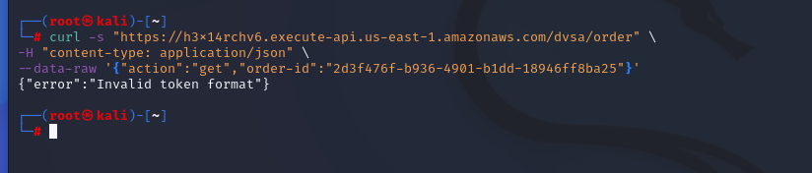
This proves that authentication exists and the API does not allow completely unauthenticated access.
Second, after using a valid token from User B together with the victim’s order-id, the API returned:
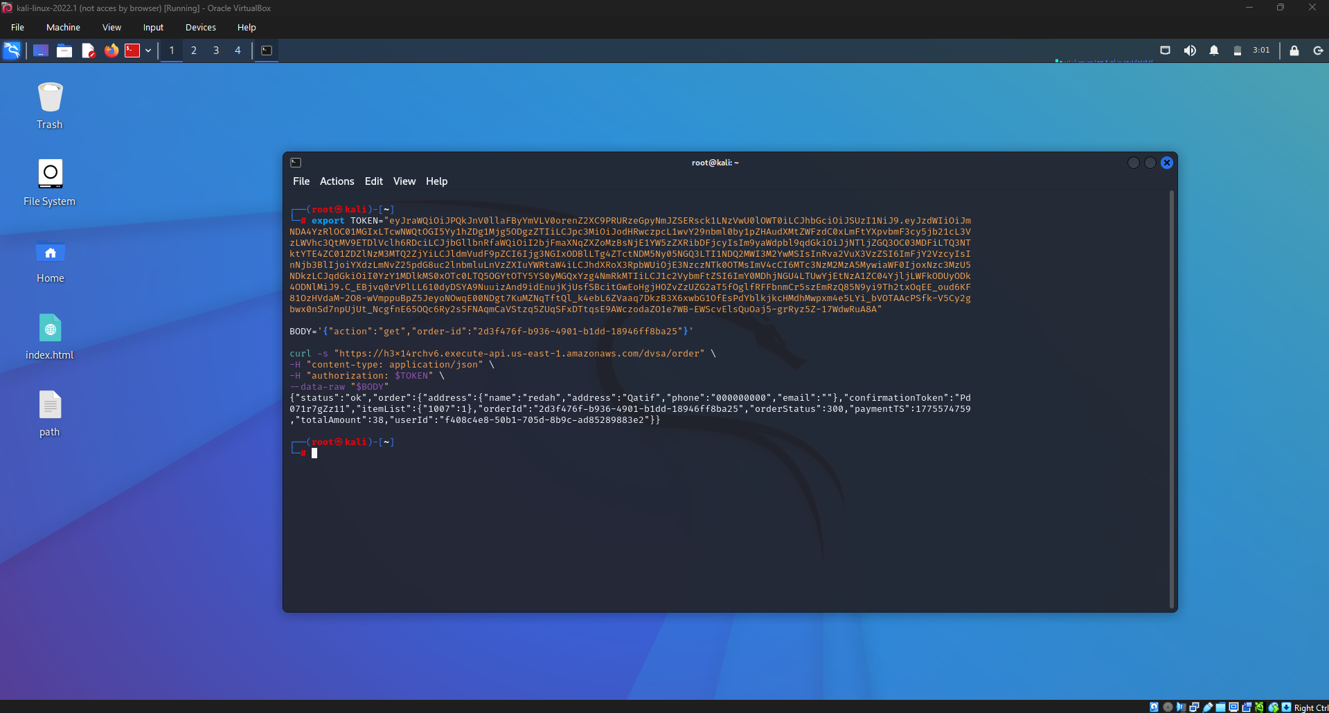
This proves that the backend returned another user’s sensitive information including address, phone number, payment information, and user ID without verifying ownership.
This confirms Sensitive Information Disclosure caused by missing authorization checks.

Fix Strategy / Probable Mitigation
The correct security fix is to enforce ownership validation before returning order or receipt details
The backend should not only verify that the user is authenticated, but must also verify that the requested order belongs to the authenticated user. Only administrators should be allowed to bypass this restriction.
In addition, backend exception handling should be improved so that internal errors do not expose stack traces or implementation details to users.
This mitigation addresses the real root cause by enforcing authorization rather than only authentication.

Code / Config Changes
Temporary Execution Patch (to complete the lesson)
Before
is_admin = json.loads(event.get("isAdmin", "false")).lower()
After
is_admin = str(event.get("isAdmin", "false")).lower()
This prevented the Lambda function from crashing and allowed the vulnerable authorization path to execute properly.
Real Security Fix
Ownership validation should be added:
if order["userId"] != userId:
return {
"statusCode": 403,
"body": "Unauthorized access"
}
This ensures users can only access their own orders.

Verification After Fix
After the temporary execution patch was deployed, the same exploit request was executed again.
Using:
User B valid token
User C order-id
the API returned the victim’s full order details successfully.
This verified that the original vulnerability was real and that the backend was processing unauthorized access requests without ownership validation.
After applying the real security fix (ownership validation), the same request should return:
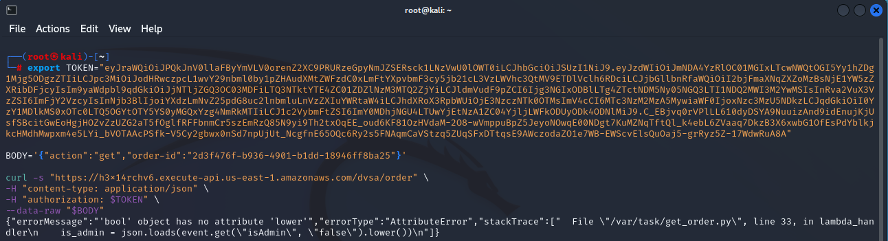
while legitimate users should still be able to access only their own orders.
This confirms that the mitigation correctly removes the vulnerability without breaking normal functionality.

Structured Operation and Security Analysis

Table 1: Structured analysis summary — Table A
Vulnerability | Intended Rule(s) | Artifacts Used to Infer Rule | Normal Behavior Evi dence | Exploit Behavior Evi dence
Sensitive Information Disclosure | Users must only access their own orders and receipts. Authentication alone is not sufficient; ownership validation must be enforced. | Browser workflow, API requests, JWT token, Lambda code, terminal output, Lambda logs | requests, JWT token, Lambda code, terminal output, Lambda logs  Request without token returned “Invalid token format,” proving authentication exists | Valid token from User B + User C order-id returned victim’s full order details

Table 2: Structured analysis summary — Table B:
Vulnerability | Why This Is a Deviation | Deviation Class | Fix Applied  (where) | Post-Fix Verification
Sensitive Information Disclosure | The backend trusted order-id without verifying ownership. This violates authorization rules because attacker-controlled input was used to access another user’s sensitive data. | Intentional misuse / security-relevant abuse | Lambda function DVSA-ORDER-GET — added ownership validation and fixed isAdmin type handling | After patch, exploit successfully demonstrated the flaw; after full security fix, unauthorized requests should return 403

Takeaway / Lessons Learned
This lesson shows that authentication alone is not enough to protect sensitive data. A system must always verify both identity and authorization before returning protected resources.
In serverless applications, vulnerabilities often occur between API Gateway, Lambda, and backend storage when ownership checks are missing. Even when authentication is correctly enforced, weak authorization can still expose critical user data.
The main secure design principle learned from this lesson is:
Never trust user-controlled identifiers without validating ownership.
Every request for sensitive data must be verified against the authenticated identity, and backend errors must be handled safely to avoid additional information leakage.

